Bahria University,

Karachi Campus



LAB EXPERIMENT NO.

___11___

LIST OF TASKS

|  |  |
| --- | --- |
| TASK NO | OBJECTIVE |
| **01** | **Create Reusable Code/Software for generating Marksheet of a**  **student.** |
| **02** | **Consume Google Maps Api in Html Webpage.** |
|  |  |
|  |  |
|  |  |
|  |  |
|  |  |
|  |  |
|  |  |
|  |  |
|  |  |
|  |  |

Submitted On:

____________

(Date: DD/MM/YY)

**Task No 01:** Create Reusable Code/Software for generating Marksheet of a

student.

(Hint: Use Project 1 for calculation and Grading purpose)

**Solution:**

**Class Grading System**

namespace LAB11{

class GradingSystem {

string div, fname, lname, clases, year; int age; double total = 0, per;

public GradingSystem(string fname, string lname, string clases, string year, int age) {

this.fname = fname;

this.lname = lname;

this.clases = clases;

this.year = year;

this.age = age; }

public void calculate_percen() {

Console.WriteLine("Enter Number Of Subjects : ");

int n = int.Parse(Console.ReadLine());

for (int i = 1; i <= n; i++){

int marks;

Console.WriteLine("Enter Marks Of Subjects : ");

marks = int.Parse(Console.ReadLine());

total += marks;}

per = total / n;

if (per >= 60) div = "First";

else

if (per < 60 && per >= 48) div = "Second";

else

if (per < 48 && per >= 36) div = "Pass";

else div = "YOu are Pass but not . Do more efforts to clear this round :-)"; }

public void display(){

Console.WriteLine("\t\t\t-------------------- Marksheet-------------------- \t\t\t");

Console.WriteLine();

Console.Write(" FirstName is {0}\n", fname);

Console.Write(" LastName is {0}\n", lname);

Console.Write(" Class is {0}\n", clases);

Console.Write(" Year is {0}\n", year);

Console.Write(" AGe is {0}\n", age);

Console.WriteLine();

Console.Write("Total Marks = {0}\nPercentage = {1}\nDivision = {2}\n", total, per, div);} } }

**Main Method**

namespace LAB11{

class Program{

static void Main(string[] args){

Console.WriteLine("---------------------------------");

Console.WriteLine("Your First Name : ");

string fname = Console.ReadLine();

Console.WriteLine("Your LastName : ");

string lname = Console.ReadLine();

Console.WriteLine("Your class : ");

string clases = Console.ReadLine();

Console.WriteLine("Your year : ");

string year = Console.ReadLine();

Console.WriteLine("Your age : ");

int age = int.Parse(Console.ReadLine());

GradingSystem obj = new GradingSystem(fname, lname, clases, year, age);

obj.calculate_percen();

obj.display();

Console.WriteLine("---------------------------------"); }}}

**Output:**

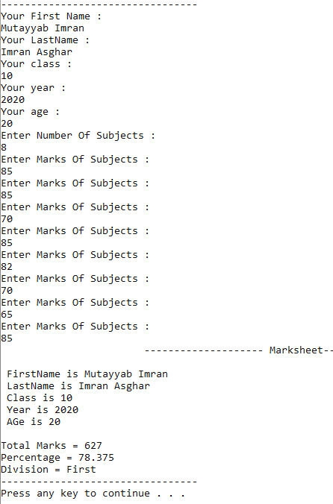

Ul Hassan

Adeeb

Ul Hassan

Adeeb

**Task No. 2:** Consume Google Maps Api in Html Webpage.

**Solution:**

**Script File**

<script> <script src="https://maps.googleapis.com/maps/api/js?key="></script>

function initMap() {var mapOptions = { center: { lat: 3.456, lng: 5.46 }, zoom: 8.6 };

var map = new google.maps.Map(document.getElementById('map'), mapOptions); }

</script>

**HTML File**

<div id="map"></div>

**Output:**

